PROJECT TITLE:

CMS WEBSITE DEVELOPMENT

INTERNSHIP

REPORT

TAN WEI JUN, TERRIS

172737L

IT3699 INTERNSHIP PROGRAMME

AY 2019/2020 (Period 1)

DIPLOMA IN BUSINESS INFORMATICS

SCHOOL OF INFORMATION TECHNOLOGY

NANYANG POLYTECHNIC

ACKNOWLEDGEMENTS

Rodwin Alvarez - IIM/ Work Supervisor/ Senior

Cao Wei - Work Supervisor/ Senior

TABLE OF CONTENTS

SECTIONS

1.0 ORGANISATION BACKGROUND………………………………...….……………...……... 5

1.1 Background……………………………...…………………....………...………….... 5

1.2 Nature of Business…………………..…………………..…………...………...… 5

1.3 Organisation Chart………………………………………...………...………...…. 6

1.4 Platform and Technology……………………………………………...…...…… 7

2.0 ATTACHMENT BACKGROUND………………………………………………….....………. 8

2.1 Department and Department Role…………………………...…………… 8

2.2 Organisation Chart of Department……………………………...………… 8

2.3 Attachment Details……………………………………………………......……… 9

3.0 PROJECT BACKGROUND………………………………………………....………...……... 10

3.1 Project Name and Background……………………...……………...……… 10

3.2 Project Development Softwares……………………………………...….. 10

3.3 Project Scope………………………………………………………………......…… 11

3.4 Project Description…………………………………………………...…...……… 11

4.0 PROJECT SCHEDULE………………………………………………………..…………....……. 13

4.1 Project Gantt Charts………………………………………..……………...……. 13

4.1.1 Project Gantt Chart Month 1……………………………...…….. 13

4.1.2 Project Gantt Chart Month 2……………………………...…….. 13

4.1.3 Project Gantt Chart Month 3………………….…………...…….. 14

4.1.4 Project Gantt Chart Legend………………………………...…….. 14

4.2 Project Explanation……………………………………………….……….....….. 15

4.3 Project Tasks………………………………………………………………….....….. 15

4.4 Project Manpower and Time Frame………………………………...….…. 17

5.0 PROJECT ACCOMPLISHMENTS…………………………………………..………...……. 18

5.1 Approach of Tasks Completion…………………………..…………...……. 18

5.2 Expected Deliverables………………………………………...…………....…. 18

5.3 Problems Faced and Resolvement……………………………………...... 19

5.4 Experience Gained and Lessons Learnt……………………….…………... 19

6.0 ANALYSIS OF ASSIGNMENT/RECOMMENDATIONS FOR IMPROVEMENT.... 20

1.0 Organisation Background

1.1 Background

The assigned company for my internship is GT Group of Companies, specifically GT Dollar Pte Ltd. The address of the company is 10 Kallang AVE #13-18, Aperia Tower 2, Singapore 339510. The headquarters of the business is in Singapore, with several regional offices across Asia-Pacific region.

GT Group comprises of GT Dollar, GT Robot, GT Mobile, GT Payment and more. Each having their own products and objectives.

From their self-description, GT Group of Companies is a group seeking to materialize the GT eco-system in realizing its mission to empower every individual with an affordable yet high quality hardware augmented with innovative software solutions in pursuit of a Smart Nation.

1.2 Nature of Business

The products and services ranges from robots to phones to cryptocurrency. In short, GT Group is a hybrid business that sells robots and phones (manufacturing), and provide currency and payment services (service).

As briefly mentioned, GT Group is also a local private company that is private limited. This treats the company as an entity separated from the members that make up the company and as a “person” in law. As a private limited company, the company is limited by fifty or less shareholders and shareholders are not liable for the debts of the company.

To summarize, the nature of business of GT Group is a hybrid business type in the form of a private limited business organization in Singapore.

1.3 Organisation Chart

Appendix A, GT Group of Companies.

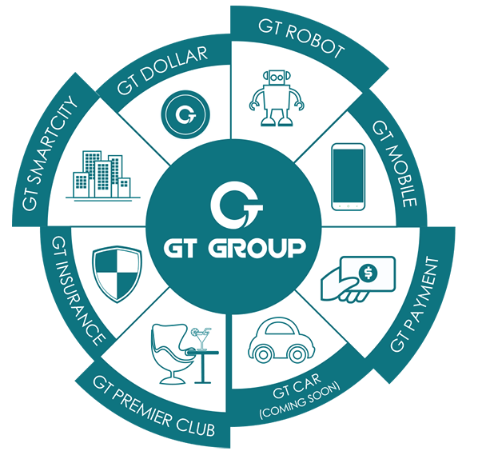

With reference to Appendix A, GT Group comprises of GT Dollar, GT Robot, GT Mobile, GT Payment, and more. From this information, the organization chart of GT Group is derived as shown:

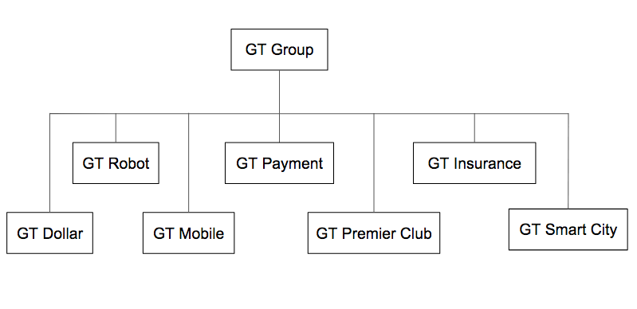

1.4 Platform and Technology

The equipment provided by the company varies from department to department. However, there are also commonly shared equipment. In the company, they provide a variety of brands of computer sets and laptops for employees to use. A computer set includes a monitor, wires, a wireless keyboard, and a wireless mouse. The brands of hardware includes, but not limited to, Apple iMac, HP, Dell, and Lenovo.

In my department, majority uses any free software online. For sharing of documents, we use Google Suite applications. As of programming platforms, it varies from project to project. For my section’s project, we use a variety of platforms. They are PyCharm Community Edition, MongoDB Compass, and DialogFlow.

Through observation, the company’s use of technology is very flexible as we do not rely on a single development platform and can easily switch to another. Hardware equipment is also readily available.

2.0 Attachment Background

2.1 Department and Department Role

Within the GT Group, I was assigned to the GT Robots department, specialized in creating, modelling and adding programs into robots. We only make the prototypes of the robots and heavily test it before deployment. The mass manufacturing of robots are done separately in an external factory.

Currently, my department has 3 types of robots available for sale. Each of these robots have their own appearances and a set of functionalities. To give an example, during my internship, I was able to test the GT Wonder Boy robot. The smallest robot product and the most likeable companion. It is a handheld robot that can also stand, move, and perform by its own. It is a companion robot because the main interactivity comes from talking to it.

2.2 Organisation Chart of Department

The size of my department is very small, consisting of only 13 members and 3 interns, myself included. We are divided into sections. Each section is given their own set of tasks and are to become the expertise of their own field. The tasks are based on the different functions of different robots. Hence, there is no fix organisation chart for my department.

For my internship, I was assigned into the AI team where we create and maintain the Natural Language Processing (NLP) of the GT Wonder Boy. With this in mind, the NLP platform used was the DialogFlow browser. Being an intern, I was tasked not to directly handle the original DialogFlow document, but instead, create a CMS Website.

2.3 Attachment Details

My internship attachment started on 4 March 2019 and ends on 24 May 2019. Over a span of 12 weeks. During my internship I was under the guidance and supervision of an IIM, industry internship mentor, and a SIM, school internship mentor. My IIM was my colleague Rodwin Alvarez, and my SIM was Mr Chee Yong Law.

There, my role was to help as much as I could and being helpful to the team I was assigned to by doing anything within my capabilities. Overtime, I learned various new platforms to implement into the project, such as APIs, plugins, and databases.

3.0 Project Background

3.1 Project Name and Background

The name of my first assigned project was labelled “CMS Website”. A CMS Website is an acronym for Content Management System Website. This project aims to provide a platform, in this instance a website, for our clients to interact and add their own custom questions and responses in their own GT Wonder Boy.

Currently, the target audience of the CMS Website are businesses and corporations as it serves as a platform to create custom FAQs for their GT Wonder Boy. It can be used to serve individuals as well.

To explain the context, the GT Wonder Boy is a handheld robot. Within the robot is an application installed that allows users to verbally talk and give commands to it. The application acts as a medium to connect the GT Wonder Boy to DialogFlow then to the CMS Website. Refer to Appendix B.

Appendix B, GT Wonder Boy to CMS Website.



With this application and DialogFlow, the CMS Website was introduced to allow users to make their own custom commands. Hence, the CMS Website project.

3.2 Project Development Softwares

To achieve the goals of the CMS Website, we decided to incorporate DialogFlow to make use of intents. As for the IDE platform, we used PyCharm and created the project with backend Python. As development progressed, we also implemented other extensions such as AJAX, Bootstrap, JSON, and Flask Framework. All programming were accomplished on an iMac and desktop.

3.3 Project Scope

The CMS Website is dedicated to allow users to be able to create their own custom sets of FAQ. A set of FAQ consists of an intent, up to 10 questions, and an answer. Hence, the project scope was to create a website while incorporating the DialogFlow API. Other goals to be achieved were user guides, FAQ construction rules, and a staff account variant to manage all users.

With the main goal in mind, the CMS Website was envisioned to be able to handle all custom intent needs. Hence, the priority of the CMS Website was to be able to add, edit, and delete intents. Besides this, we had to also filter intents based on its type. Being either drafted or saved.

3.4 Project Description

The idea of the CMS Website came about to give users the capability to add their own unique speech and responses to their own GT Wonder Boy. The speech is designed such that the GT Wonder Boy will be able to detect similar questions, while the responses was designed to give the same answer for that FAQ set.

Whenever the user creates, edits, or removes an intent, they are prompted to click “Save To WonderBoy” to save the changes and the type of the intent to “Saved”. Likewise, whenever the user creates, edit or remove an intent, the intent type will be changed to the respective types, “New”, “Edited”, “Deleted”, and visually displayed as icons on the web page.

The CMS Website was also built to consider the act of user friendliness and supports cross device usage. To be brief, the CMS Website comes with interactivities. Guides, rules, and robot manuals were all in the form of interactive tables or lists. This made learning the website less dull for our users, captivating them to continue using our product, and eventually market the product through word-of-mouth as customer royalty builds. With cross device, the website is also mobile friendly as we have incorporated Bootstrap elements into each and every web page, enabling users to use it on the go. The bootstrap elements mostly include CSS media queries. Other features include changing password.

For the staff account, the staff were granted access to create and reset the passwords of any account in both account types. Staff accounts were also able to edit the particulars of user accounts. This is because certain confidential data are kept away and users were not supposed to be able to change them willy-nilly, such as their user Id and bot Id.

As the internship finishes, the CMS Website may continue to undergo changes and improvements to satisfy future user requirements and continue resolving bug fixes. There are even new user requests coming in as this report is being written.

4.0 Project Schedule

4.1 Project Gantt Charts

4.1.1 Project Gantt Chart Month 1

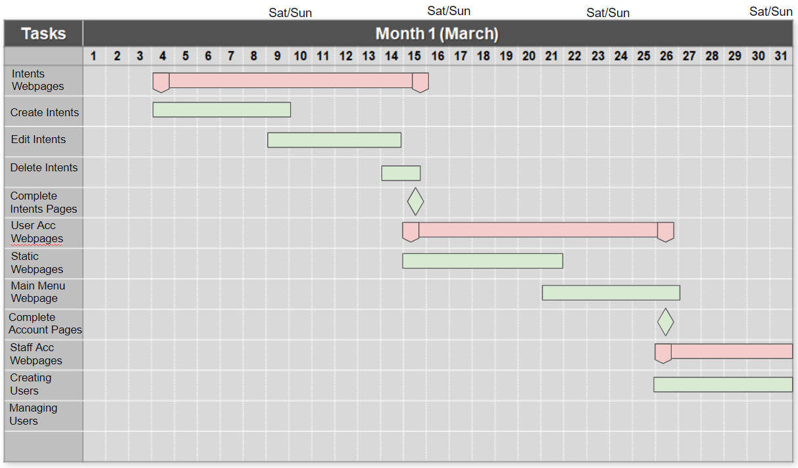

4.1.2 Project Gantt Chart Month 2

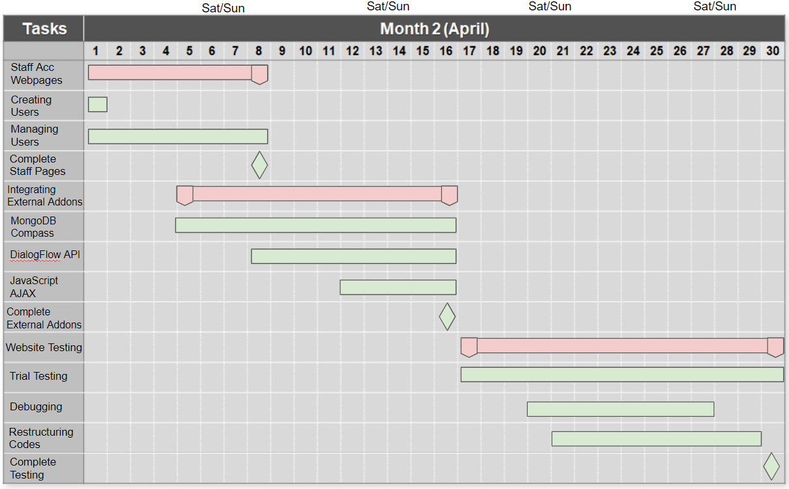

4.1.3 Project Gantt Chart Month 3

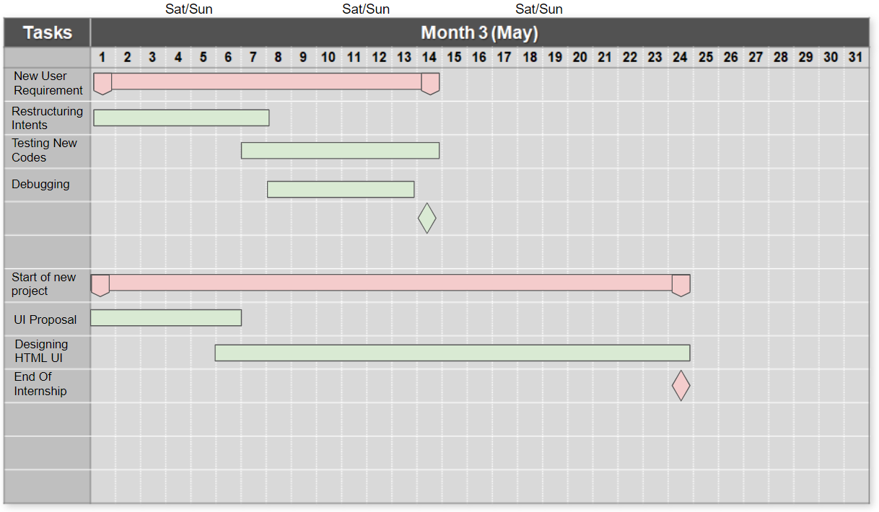

4.1.4 Project Gantt Chart Legend

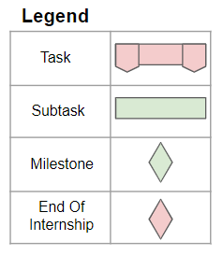

4.2 Project Explanation

The provided Gantt Charts are meant to be of point of references during the course of my internship. It does not show the true and specific time frames of each and every task, and nor does it implies that the tasks listed are limited to the ones are as shown above. It is solely used as a demonstration to share about what I have done for this project.

There are also other tasks for a given time frame, however, they were either unrelated to the project or were merely smaller tasks inside a subtask. Hence, were not portrayed in the provided Gantt Charts. The Gantt Charts will also be explicitly about my first project as the second project is currently only at the designing phase at the time of my internship, and the report limits to only one project.

The tasks are divided into tasks and subtasks, indicated by the given legend. The chronological order of time frames of each task will differ from the actual online e-Log task overview. This is to properly group and illustrate my lists of tasks given my available Gantt Chart software and to also make it easy-to-understand to lessen the complexity.

4.3 Project Tasks

From the tasks of the “CMS Website”, I have labelled them based on features and testing. They are as follows; “Intents”, “User Account”, “Staff Account”, “Integrating Addons”, “Testing”, and “New Requirements”.

The “Intents Webpages” task is focused on creating the webpages for when a general user creates, edits, or deletes an intent. At the time of starting this task development, we had yet to implement the actual DialogFlow API. Henceforth, we mainly tested it with only the given database.

The “User Account Webpages” was focused in creating the static webpages of the CMS Website. It also serves to display menus of intents, giving users the control to manage their intents from these intent menus. This was again, checked with only the given database at that time.

The “Staff Account Webpages” was a task that focused on creating staff tools that came along with the CMS Website. It prioritizes staff accounts to be able to control other accounts, allowing them to be able to create, view, and modify accounts. Both general accounts and staff accounts.

Finally is the “Integrating External Addons” task. This task had the biggest change in the project as we had to implement all of the additional plugins, APIs, libraries, and extensions. It was also the start of restructuring codes to compensate for these new code structures. The major subtasks are listed as “DialogFlow API”, “MongoDB Compass”, and “JavaScript AJAX”. Although “MongoDB Compass” was already part of the initial development of the project, there were major changes to the code structure due to new logic errors when implementing “DialogFlow API”. This further made the restructuring of codes tense and frustrating during actual development of the task.

The “Website Testing” task was to test the final works of the project after the whole integration of the external addons was complete. And once done, was the “New User Requirement” task.

To explain with context, the CMS Website was initially structured to be a question and answer pairs. But to make the question and response more vibrant with varieties of questions, we redesigned it into a “10 question and an answer” intent. Hence, the restructuring of the CMS Website to meet the “New User Requirement” task.

Alongside was the ”Start of new project” task. As this report mainly focuses on only one project, I will not be sharing the specific details. However, the project’s objective was to redesign the official GT Robots Website.

4.4 Project Manpower and Time Frame

The entire CMS Website project was done by the AI team. The tasks were divided amongst 4 people. The UI of the CMS Website and simple backend codes were done by me and my intern partner, while the extensive backend programs and supervision of the entire project were done by my seniors in the team. As illustrated from the Gantt Chart, the time frame of each task usually hovers around 2 weeks, and the entire project was completed within 2 and a half months.

Testing the website, however, may vary in manpower. The project will always be tested as development progresses. But whenever a milestone is reached, the current status of the project will be deployed for the entire department to test as well.

5.0 Project Accomplishments

5.1 Approach of Tasks Completion

My team and I have managed to complete all the basic tasks given to us to make the CMS Website function, and are now fulfilling new user requirements as more user requests from clients grows.

Through the course of development, as an individual, I had to do a lot of extensive research as many concepts were foreign to me. With a Java based background, I had to learn Python from the ground up. Every task required me to use Python programming as it was and still is the main backend programming language for the project.

After being accustomed to the numerous syntax errors in Python, I started making many short and simple algorithms, not for every webpage but for those that require the handling of data. Besides the Python algorithms, I made a large handful of JavaScript and CSS code snippets to create the numerous user interactivity in the navigation menu, mobile compatibility, tables, lists, and more.

Achieving these JavaScript and CSS interactivity had me to surf the internet for numerous ideas and samples. It was indeed fun and satisfying to be able to accomplish these tasks and get the work done.

Every webpage we made had to come with a mobile version of the UI. These made media queries came into play. With much tomfoolery, I would always somehow be able to create a bug within the intended UI design that ultimately becomes the official UI as it makes the webpage looks better.

5.2 Expected Deliverables

My expected deliverables as a web developer role was to create each webpage and link them together. I was also expected to connect certain backend codes and ensure that they were working as intended, being it either to modify the codes or informing my colleagues of the issues I come across. Besides these, I would also be expected to do test runs with the whole website whenever a milestone is reached.

5.3 Problems Faced and Resolvement

After a certain point in the project, small problems would pop up every now and then. Problems includes, but not limited to, bugs in mobile UI, DialogFlow API connection fail errors, unintended flow of codes, and more.

These errors would usually be fixed quickly, but to those that were unable to, we would always find a workaround by restructuring the codes entirely.

Mobile UI bugs were always related to the CSS media queries and JavaScripts, and would take at most a single day to resolve.

DialogFlow API connection fail errors was an error from the provider’s side, to resolve this error was to simply create a loop to retry the DiaFlow API connection code.

Other errors would be logic errors that would take awhile to fix, but never too hard. And if so, we would work around it, finding alternatives that can meet the same objective.

5.4 Experience Gained and Lessons Learnt

The experience from this internship was quite immense and a lot of lessons could be learnt from it. Overall as an individual seeking for a web developer profession, I gained much skill and knowledge about the types of UIs for the different purposes of websites. For instance, e-commerce websites require a homepage that instantly hooks visiting users, while CMS Website requires a guide page for users to learn how to use the website.

I learned many important habits to adopt when coding, such as shortening codes, commenting frequently, and dividing codes into reasonable sized functions/methods.

For software and APIs, I learned to use online repositories, DialogFlow, and MongoDB. HTML wise, I learned AJAX, CSS media queries, and improved in structuring JavaScript codes.

With technical skills aside, I have gained various soft skills as well. I have built on my patience from the loading times of webpages, built a strong work ethic from the daily work routines of the office, be optimistics when coding, have good communication skills to be on the same task at hand, manage time wisely for the day, adopt problem solving skills when test running, be self confident when modifying codes, and being able to embrace changes when a new user requirements comes into play.

6.0 Analysis of Assignment/Recommendations for Improvements

Besides what I have mentioned above in section 5.4 Experience Gained and Lessons Learnt, I have overall become a better web developer and as a person.

This internship has given me insights on how businesses are being run, and how programmers and developers live their day-to-day life in the workplace. In all, it gave me a small taste of what being a programmer will be like as a career choice, and has motivated me in striving for it after experiencing this internship first hand.

There are also many other factors as well that have taught me what being a working adult is like in a workplace. However, those are minor details that do not go along with being a programmer. In short, I learned some basic and common etiquette to adopt as a working adult.

To set aside a goal to self improve myself, I believe that reflecting about my internship can further help improve my skills as I can reflect on my flaws and areas that I can make self improvements on.